Pre-Beta Demo Test

Description

This test will follow the process of beta demo, which is described in the document *“ECSE211-W21-Beta-Demo-V2.0”* in myCourse.

Testing Map:

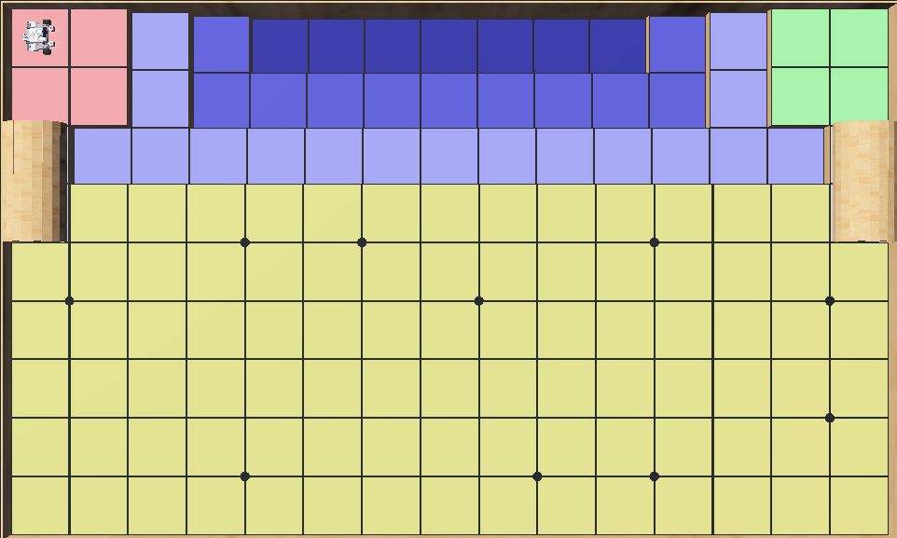

**Test 1**

**Date:** 2021/3/24

**Tester:** Junjian Chen

**Author:** Junjian Chen

**Hardware version:** 1.3 (in Part 2.5 of [Hardware Document](https://docs.google.com/document/d/11jkA_S_xBqyCbcn2NyMuM-OMDEybDfRy/edit#))

**Software version:** 1.5 (in Part 7.0 of [Software Document](https://docs.google.com/document/d/19JaY5629aUu4Y4rjoQJ-jWyeQLqNSAcr/edit))

**Test Purpose:**

Determine whether the robot is able to pass the beta demo.

**Test Procedure:**

1. Place the robot at (0.5,8.5)
2. Select a starting angle for the robot to face toward
3. Start the simulation
4. The beta demo is basically divided into 4 parts:
   1. Localization
   2. Cross the bridge
   3. Navigate to first waypoint
   4. Return back

After the simulation, observe and record whether each part succeeds or not.

**Test Data:**

|  |  |  |
| --- | --- | --- |
| Trial# | Start Angle/degree | First Way Point  /(x,y) |
| 1 | 0 | (1,4) |
| 2 | 60 | (1,4) |
| 3 | 90 | (1,4) |
| 4 | 315 | (1,4) |
| 5 | 180 | (1,4) |
| 6 | 90 | (4,1) |
| 7 | 90 | (2,2) |
| 8 | 90 | (6,5) |

**Expected Result:**

**All the trials should pass the test.**

**Test Results:**

|  |  |  |  |
| --- | --- | --- | --- |
| Trial# | Pass/Fail | Failed Part | Comment |
| 1 | Pass |  |  |
| 2 | Pass |  |  |
| 3 | Pass |  | At d, the robot is able to return but the wheel rubs to the edge of the bridge. |
| 4 | Fail | d | The robot crushes into the edge of the bridge. |
| 5 | Fail | b/c/d | The robot crushes into the edge of the bridge at part b,causing the rest of the parts to fail. |
| 6 | Fail | d | The robot fails to navigate to the endpoint of the bridge. |
| 7 | Pass |  |  |
| 8 | Fail | c/d | The robot fails to navigate to waypoint(6,5). |

**Test Report:**

Pass rate: 50%

Most of the trials fail. For trial 4,5 and 6, the reason for failure is that the angle the robot faces toward is not accurate and differs too much from the minimal angle between start and end point of the bridge. For trial 8, the robot cannot navigate to the waypoint because of the limitations of the method of light localization.

**Conclusion:**

Since most of the trials fail, the test fails.

**Action:**

Modify the methods of light localization to improve the accuracy of angles when passing through the bridge.

Try to set a “pre-passing point” before passing the bridge.

**Distribution:**

Software Developent

**Test 2**

**Date:** 2021/3/24

**Tester:** Junjian Chen

**Author:** Junjian Chen

**Hardware version:** 1.3 (in Part 2.5 of [Hardware Document](https://docs.google.com/document/d/11jkA_S_xBqyCbcn2NyMuM-OMDEybDfRy/edit#))

**Software version:** 1.6 (in Part 7.0 of [Software Document](https://docs.google.com/document/d/19JaY5629aUu4Y4rjoQJ-jWyeQLqNSAcr/edit))

**Test Purpose:**

Determine whether the robot is able to pass the beta demo.

**Test Procedure:**

1. Place the robot at (0.5,8.5)
2. Select a starting angle for the robot to face toward
3. Start the simulation
4. The beta demo is basically divided into 4 parts:
5. Localization
6. Cross the bridge
7. Navigate to first waypoint
8. Return back

After the simulation, observe and record whether each part succeeds or not.

**Test Data:**

|  |  |  |
| --- | --- | --- |
| Trial# | Start Angle/degree | First Way Point  /(x,y) |
| 1 | 0 | (1,4) |
| 2 | 60 | (1,4) |
| 3 | 90 | (1,4) |
| 4 | 315 | (1,4) |
| 5 | 180 | (1,4) |
| 6 | 90 | (4,1) |
| 7 | 90 | (2,2) |
| 8 | 90 | (6,5) |

**Expected Result:**

**All the trials should pass the test.**

**Test Results:**

|  |  |  |  |
| --- | --- | --- | --- |
| Trial# | Pass/Fail | Failed Part | Comment |
| 1 | Pass |  |  |
| 2 | Pass |  |  |
| 3 | Pass |  |  |
| 4 | Fail | b/c/d | The robot crushes into the edge of the bridge at part b. |
| 5 | Pass |  |  |
| 6 | Pass |  |  |
| 7 | Pass |  |  |
| 8 | Fail | c/d | The tail of the root crushes into the wall when it is turning toward (6.5) |

**Test Report:**

Pass Rate:75%

After we modify the “BridgePasser” class, the rate of success increases significantly. In this test, most of the trials pass. Trial 4 fails because of the inaccuracy of light localization however it seems to be accidental and is caused by the defaults of webot. Trial 8 fails because we do not leave enough space for the robot to turn.

**Conclusion:**

The robot can pass the test at most of the cases but fail at some edge cases.

**Action:**

Set a “before-returning point” which gives the robot enough space to turn without crushing into the wall.

**Distribution:**

Software Developent

**Test 3**

**Date:** 2021/3/25

**Tester:** Junjian Chen

**Author:** Junjian Chen

**Hardware version:** 1.5 (in Part 2.5 of [Hardware Document](https://docs.google.com/document/d/11jkA_S_xBqyCbcn2NyMuM-OMDEybDfRy/edit#))

**Software version:** 1.7 (in Part 7.0 of [Software Document](https://docs.google.com/document/d/19JaY5629aUu4Y4rjoQJ-jWyeQLqNSAcr/edit))

**Test Purpose:**

Determine whether the robot is able to pass the beta demo.

**Test Procedure:**

1. Place the robot at (0.5,8.5)
2. Select a starting angle for the robot to face toward
3. Start the simulation
4. The beta demo is basically divided into 4 parts:
5. Localization
6. Cross the bridge
7. Navigate to first waypoint
8. Return back

After the simulation, observe and record whether each part succeeds or not.

**Test Data:**

|  |  |  |
| --- | --- | --- |
| Trial# | Start Angle/degree | First Way Point  /(x,y) |
| 1 | 0 | (1,4) |
| 2 | 60 | (1,4) |
| 3 | 90 | (1,4) |
| 4 | 315 | (1,4) |
| 5 | 180 | (1,4) |
| 6 | 90 | (4,1) |
| 7 | 90 | (2,2) |
| 8 | 90 | (6,5) |

**Expected Result:**

**All the trials should pass the test.**

**Test Results:**

|  |  |  |  |
| --- | --- | --- | --- |
| Trial# | Pass/Fail | Failed Part | Comment |
| 1 | Pass |  |  |
| 2 | Pass |  |  |
| 3 | Pass |  |  |
| 4 | Pass |  |  |
| 5 | Pass |  |  |
| 6 | Pass |  |  |
| 7 | Pass |  |  |
| 8 | Pass |  |  |

**Test Report:**

Pass Rate:100%

All trials pass the test.

After using the robot of hardware version 1.5, which shortens the tail of the robot, the possibility of crashing into the bridge while turning lowers.

After using software version 1.7, which sets a “after-passing point” at (1,4), the robot will navigate and localize to this point after entering the main island or returning back to the starting position. This will reduce the deviation of angle and prevent the crushing.

**Conclusion:**

The test passes.

**Action:**

None

**Distribution:**

Software Developent